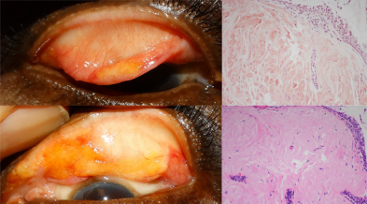

A 62-year-old man presented with visually significant ptosis of the bilateral upper eyelids. Levator function was normal with noevidence of lagophthalmos. Lid eversion demonstrated bilateral soft, nontender, yellow-white masses on the upper palpebral conjunctiva(A-B). The remainder of the ocular examination was unremarkable. Intraoperative biopsies of both eyelids revealed the amorphousextracellular, eosinophilic deposition seen in amyloid, and confirmed with Congo red (C) and crystal violet staining (D). Systemicinvolvement was ruled out with a normal serum-free light chain ratio with negative serum electrophoresis. Based on the provided images and clinical description please make an ophthalmic diagnosis for this patient. And output the diagnostic conclusions only.

**Ophthalmic diagnosis: Conjunctival amyloidosis**